South Metro Racial Justice and Equity Project
Capacity Building for Racial Justice in South Metro Region

INTRODUCTION
Seeding Justice is a nonprofit organization funding grassroots social and racial justice focused organizations that work to dismantle injustices in our communities.
Seeding Justice has received American Rescue Plan Act (ARPA) dollars to build the capacity of small, community-based organizations that are working toward a racially just community in the South Metro region, specifically in Lake Oswego, West Linn, Tualatin, Southwest Portland, Rivergrove, and Durham.
The South Metro Racial Justice and Equity Project (SMRJ) will provide up to ten selected organizations with both financial resources and capacity building support in the areas of:
- Anti-Racism and Cross Cultural Engagement
- Operations and Finance
- Governance
- Movement Building and Community Organizing
- Care and Healing
- Fundraising and Communications
(For more on what these areas encompass, please check out this document on our website.)
The SMRJ will utilize a cohort model that over a two-year period, will provide selected organizations with:
- Annual operating support grants of up to $30,000 per year ($60,000 total over two years);
- Opportunities for networking, learning, and convening with other like-minded organizations in their region; and
- No-cost technical assistance and consulting in areas of need the organization identifies.

ELIGIBILITY
To be eligible to apply, an organization must:
- Have their 501(c)(3) status or be fiscally sponsored by a 501(c)(3) organization. (If you need more information, please contact us with any questions about 501(c)(3) or fiscal sponsorship status);
- Be led by and/or work in close partnership with Black, Indigenous, other people of color, and/or communities impacted by systemic oppression, especially those who were and continue to be disproportionately impacted by COVID;
- Have a current annual budget of $500,000 or less; and
- Work toward benefiting communities in Lake Oswego, West Linn, Tualatin, Southwest Portland, Rivergrove, and Durham.

PRIORITIES
In selecting organizations to participate in the SMRJ, we will be prioritizing those that:
- Are committed to anti-racist work, i.e. the active engagement in organizing that seeks to name and dismantle white supremacy, and individual, institutional, and systemic racist practices;
- Are engaged in community organizing or other work that builds power for those most impacted by racial injustice;
- Are in need of capacity building in order to expand, grow, or provide better services/programs;
- Have dedicated staff or volunteers who can commit at least 10 hours per week to the cohort's work, and are ready and in a position to actively participate in the process; and
- Are open to cross learning and cross sector collaboration, and see the benefit of shared learning spaces.

DECISION MAKING
All funding decisions will be made by the SMRJ's grant review committee, which will be composed of a diverse group of folks who are often excluded from decision-making spaces.
Grant reviewers will live and/or work in the South Metro region, and bring to the table their lived experience and professional expertise around racial and social justice.

TIMELINE
The timeline for this opportunity is as follows:
- Wednesday, July 27 – Cohort applications open.
- Friday, August 26 – Deadline to apply. Applications must be submitted by 5 p.m. PST.
- By late September – Grant Review Committee makes decisions, organizations are notified, and selected participants/grantees receive materials to prepare for their first convening.
- Mid October – First cohort convening!

QUESTIONS?
If you have questions, please visit our website or send us an email and we’ll get back to you within 48 hours.
If you experience technical difficulties with Submittable, please contact them directly at support@submittable.com.

** Application questions follow in the next page**

SMRJ Cohort Application
THIS FORM IS PROVIDED FOR REFERENCE ONLY. PLEASE SUBMIT YOUR APPLICATION ONLINE AT SEEDINGJUSTICE.SUBMITTABLE.COM.
Questions with an * are required

Name of Organization* If your legal name and DBA are different, please enter both. For example: MRG Foundation, DBA Seeding Justice

Website If you don't have a website, you may enter the URL of one of your social media platforms, e.g. instagram.com/seedingjustice or facebook.com/seedingjustice

Mailing Address*

What's your organization's tax-exemption status?* If you need more information, please contact us with any questions about 501(c)(3) or fiscal sponsorship status
- 501(c)(3) exempt
What's your Employer Identification Number?* If you need to find your EIN, you can check here: https://justice.oregon.gov/charities
- Fiscally sponsored or in the process of obtaining a fiscal sponsor
What’s the name of your fiscal sponsor?
What's your fiscal sponsor’s Employer Identification Number?* If you need to find your fiscal sponsor’s EIN, you can check here: https://justice.oregon.gov/charities
What’s your fiscal sponsor’s mailing address

ABOUT YOUR ORGANIZATION
What is your organization's annual operating budget?*
- Under $100,000
- $100,000 to $300,000
- $300,000 to $500,000

Please upload your organization's current operating budget.* If you need a budget template, you may download one here.

Tell us about your organization. Please include your vision, mission and overall programs/activities?* Limit: 300 words

How does your organization practice its commitment to anti-racism? What are some examples of how anti-racism shows up in the work your organization does?* Limit: 300 words. You can check out our glossary to find out what we mean by "Anti-racism."

CAPACITY BUILDING STRENGTHS AND NEEDS
In organizational development, organizations “build their capacity” when they strengthen their ability to do more and/or better work (and do so more sustainably) by investing in their own learning, skills, and infrastructure. For the purposes of this program, we also define capacity building as:
- Identifying and creating a strong organization infrastructure that sets the conditions to support movement builders and movement building goals
- Building skills and knowledge of movement builders to achieve goals
- Grounding organizations in transformative, anti-racist practices that seek to dismantle (not replicate) white supremacist systems—especially considering anti-racism work in COVID times—and to promote relational, life supporting practices.

Overall, what are some capacity building needs your organization currently has? Select all that apply.* If you need help with any of these terms, please contact us.
- Organizing for change, including community organizing, digital organizing, and systems organizing
- Care Models, including community care, tools for healing, and organizational safety and care plans
- Governance, including board of director models, shared leadership, organizational structure models, and consensus and decision making models
- Operations, including budgeting and accounting; operations (HR, office management, technology, etc.); and decision-making and consensus models
- Sustainability, including fundraising, development, and communications
- Cross-cultural engagement, including community engagement, promoting deeper understanding across communities, and addressing and eradicating oppressive practices.
- Anti-racism models, including helping staff/board adopt or strengthen explicit commitments against racism, especially anti-Black racism; taking action to identify and eradicate racist policies, practices, and systems; and rejecting neutrality, and actively responding to issues that impact people of color.
What do you feel are the most important things your organization needs to learn or develop in your organizing work, specifically in relation to racial equity and justice?* Limit: 300 words

What do you hope your team might be able to know, do, or undo through participating in the cohort? Are there any work areas that you feel are particularly important but hard to develop at this time? Are there things you would like to be able to do but can't (or aren't sure how to) make them happen?* Limit: 300 words

What do you feel your organization does well and why? What are some relationships and/or ways of working your team values or considers important regarding the work you do?* Limit: 300 words

What has been the impact of COVID on your organization? Please include both challenges and/or opportunities that have emerged.* Limit: 200 words

SOCIAL-ECOLOGICAL MODEL
This project will use a Social-Ecological Model of Racism and Anti-Racism.
The Center for the Study of Social Policy says, "Framing racism and anti-racism within a social-ecological model promotes both an understanding of the multifaceted, overlapping, and interactive factors that contribute to and maintain racial inequities, and strategies that can be employed across multiple levels in order to eliminate racism, address its multiple impacts, and achieve a more just society."

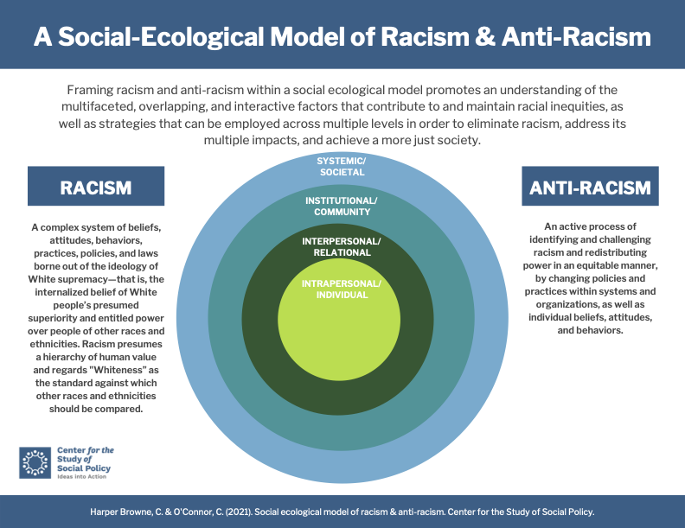

Referencing the model, where do you see your organization working? Please select all that apply. *
- Intrapersonal/Individual
How do you work at the Intrapersonal/Individual level? What do you do well/not so well and why? Limit: 300 words
- Interpersonal/Relational
How do you work at the Interpersonal/Relational level? What do you do well/not so well and why? Limit: 300 words
- Institutional/Community
How do you work at the Institutional/Community level? What do you do well/not so well and why? Limit: 300 words
- Systemic/Societal
How do you work at the Systemic/Societal level? What do you do well/not so well and why? Limit: 300 words

COMMUNITY REPRESENTATION
This space is intended to encourage reflection around relationships, power, and participation. We recognize that 'self' identifying others in your organization may feel counterintuitive, and that choosing labels or "boxes" may come off as overly simplistic/reductive. Having said that, it would be helpful to us to learn about as many of your identities as possible, so we have broken down some initial categories that include race, ethnicity, economic status, disability status, and various lived experiences, but encourage you to also expand on these identities in ways that are meaningful to you.
How do your organization's members identify? Please enter the number of people in each category that applies.*
RACE/ETHNICITY | Senior Staff (ED, Directors) | All other Staff | Board of Directors
African
American Indian / Alaska Native
Arab/Middle Eastern/North African
Asian / East Asian (China, Japan, Mongolia, North Korea, South Korea, Taiwan)
Asian / Southeast Asian (Brunei, Cambodia, Indonesia, Laos, Malaysia, Myanmar, Philippines, Singapore, Thailand, Timor-Leste, Vietnam)
Asian / South Asian (Bangladesh, Bhutan, India, Nepal, Pakistan, Sri Lanka)
Black / African American
Indigenous from Mexico, Central America or South America
Latinx / Latina / Latino / Hispanic
Mixed Race / Multi-racial
Pasifika/Native Hawaiian/Pacific Islander
Russian / Slavic
White
Other/Don’t know
LIVED EXPERIENCE | Senior Staff (ED, Directors) | All other Staff | Board of Directors
Caregiver
Displaced (climate, gentrification, other experience)
Homelessness
Incarcerated/criminalized
Immigrant
Foster care
Low income/experiencing poverty
Military veteran
Person of faith
Refugee
Survivor (abuse, neglect, assault)
Other/Don’t know
AGE | Senior Staff (ED, Directors) | All other Staff | Board of Directors
Adult
Elder
Youth
Other/Don’t know
DISABILITY | Senior Staff (ED, Directors) | All other Staff | Board of Directors
Disabled/people with disabilities
Non-disabled/people without disabilities
Other/Don’t know
GENDER | Senior Staff (ED, Directors) | All other Staff | Board of Directors
Agender
Intersex
Men
Non-binary
Third gender (including culturally specific genders)
Transgender
Women
Other/Don’t know
SEXUALITY | Senior Staff (ED, Directors) | All other Staff | Board of Directors
Asexual
Lesbian, gay, bisexual, queer
Straight/Heterosexual
Other/Don’t know

OPTIONAL: What are other identities that are important to your organization or the people you serve? Limit: 200 words

